In Asp.Net MVC, Layouts are like as Master Pages in Asp.Net Web Forms. These helps us to maintain consistent look and feel across all the views within your Asp.Net MVC application. Like Master Pages, Layout may contains common CSS, jQuery files across the multiple Views and one or more placeholders for which Views provide content. For layout and its components refer this article [Layouts, RenderBody, RenderSection and RenderPage in ASP.NET MVC](http://www.dotnet-tricks.com/Tutorial/mvc/9Ya6290314-Layouts,-RenderBody,-RenderSection-and-RenderPage-in-ASP.NET-MVC.html).

In Asp.Net MVC, at application level we have _ViewStart file with in Views folder for defining the default Layout page for your Asp.Net MVC application. In this article, I am going to expose the different ways to apply layout pages for your application. Suppose we have to render the layouts as shown in the fig. by using various ways.

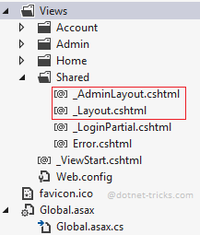

**Method 1 : Control Layouts rendering by using _ViewStart file in the root directory of the Views folder**

We can change the default rendering of layouts with in _ViewStart file by using the below code:

1. **@{**
2. **var controller = HttpContext.Current.Request.RequestContext.RouteData.Values["Controller"].ToString();**
4. **string layout = "";**
5. **if (controller == "Admin")**
6. **{**
7. **layout = "~/Views/Shared/_AdminLayout.cshtml";**
8. **}**
9. **else**
10. **{**
11. **layout = "~/Views/Shared/_Layout.cshtml";**
12. **}**
14. **Layout = layout;**
15. **}**

**Method 2 : Return Layout from ActionResult**

We can also override the default layout rendering by returning the layout from the ActionResult by using the below code:

1. **public ActionResult Index()**
2. **{**
3. **RegisterModel model = new RegisterModel();**
4. ***//TO DO:***
5. **return View("Index", "_AdminLayout", model);**
6. **}**

**Method 3 : Define Layout with in each view on the top**

We can also override the default layout rendering by defining the layout on the view by using the below code:

1. **@{**
2. **Layout = "~/Views/Shared/_AdminLayout.cshtml";**
3. **}**

**Method 4 : Adding _ViewStart file in each of the directories**

We can also set the default layout for a particular directory by putting _ViewStart file in each of the directories with the required Layout information as shown below:

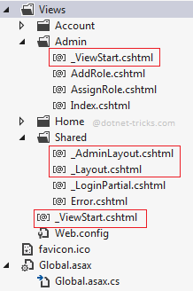

1. **@{**
2. **Layout = "~/Views/Shared/_AdminLayout.cshtml";**
3. **}**